ASSIGNMENT-1

REGISTRATION PAGE USING HTML AND

CSS

|  |  |
| --- | --- |
| STUDENT NAME | SANTHOSH KUMAR M |
| REGISTER NO | 95071912082 |

CODE:

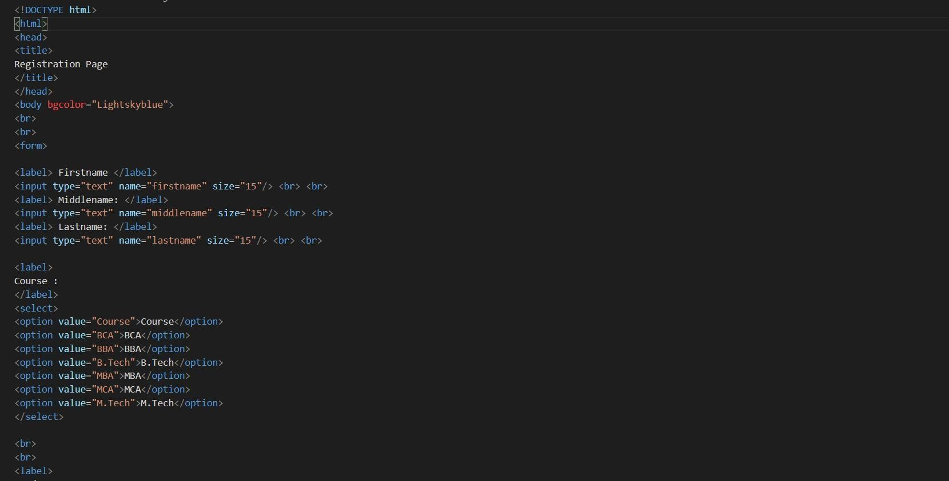

OUTPUT: